Wynds Point Quarry Grid ref: 76444046
Prior to the eleventh century the Malvern countryside was wild and wooded – a remote uninhabited wilderness.
In 1066 William the Conqueror brought about change and one of those changes was to decree that throughout the whole country, large tracts of land were to be designated royal forest, set up specifically for the hunting of deer, a privilege he reserved for himself and his chosen few. These forests were to have their own, very harsh laws, set up to protect both the deer and their environment. The size of the original forest is not known, and it is believed to have changed in size over the centuries. In the 16th century Malvern Chase covered the 13 parishes surrounding the hills, although other outlying parishes may have been included at various times.
From the beginning of his reign Charles I was in dispute with Parliament. Without its support he could not levy taxes, so money he would have received had to be found elsewhere. Acting on the advice of his Attorney General Sir Robert Heath, Charles disafforested the royal forests in the early 1630s. In return for the removal of forest law, he reserved one third of the land, and this he would sell for hard cash. In the Malvern area, surveyors designated nearly 3000 acres to the King, the remainder being allocated to the parishes. The King’s Third can still be determined from the boundary ditches which remain in the landscape on the hills today.
The Domesday survey for Herefordshire dated 1086 shows that King William (the Conqueror) had granted hunting rights at Colwall and elsewhere on the west side of the Malvern Hills, to the Bishop of Hereford. But it was not until 1630, preparatory to disafforestation, that instructions to the royal commissioners clearly stated that there were two distinct parts of Malvern Chase; the Kings Chase in Worcestershire and Gloucestershire, and the Bishops Chase in Herefordshire. The name Wydiate or Wynd Gate is recorded as far back as c1278 and relates to the southern-most part of the mid section of the Malvern Hills at Blackhill, where there is a natural pass from Malvern to Ledbury, today’s A449. There is evidence to suggest that the original road from Malvern Wells via British Camp and Chance’s Pitch to Ledbury was built about 1815. This small area of land has also been known in the past as Burstners Cross and more commonly today as British Camp or Wynds Point.
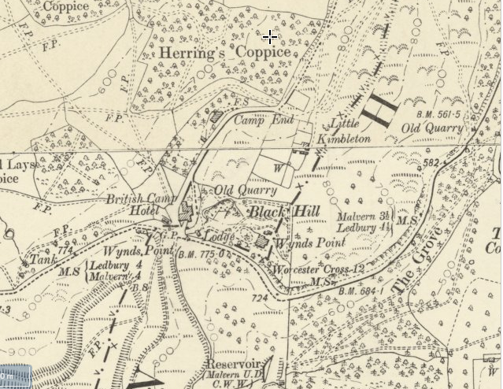
OS Map 25” to the mile 1885
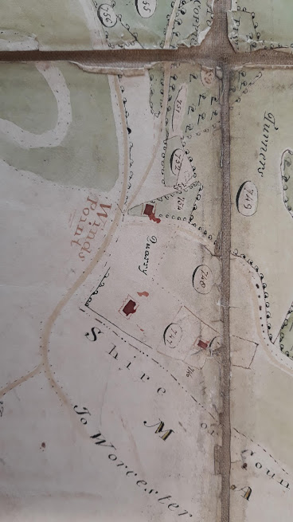
Hewing the hard stone from the side of the track for road repairs is evident throughout the Malvern Hills and would have commenced in ancient times when trackways were first laid down. The condition of the majority of the roads throughout the country up to the 18th century was generally appalling, culminating in the passing of various Turnpike Acts, the Ledbury Turnpike Trust being formed in 1721 and the Worcester Turnpike Trust in 1726. They remained responsible for the highways until the county councils took over responsibility in the 1890’s. Both Ledbury and Upton-Upon-Severn Turnpike Trusts bought their stone from Wynds Point.
This beautiful map of Colwall above drawn in 1830 shows land ownership and usage as in 1812. The only quarry depicted on this map is at Wynds Point, which would imply that it was the major and perhaps only source of large quantities of granite in the area during the early 1800’s. The photo shows the quarry behind the hotel and the junction of Jubilee Drive with the Malvern – Ledbury road.

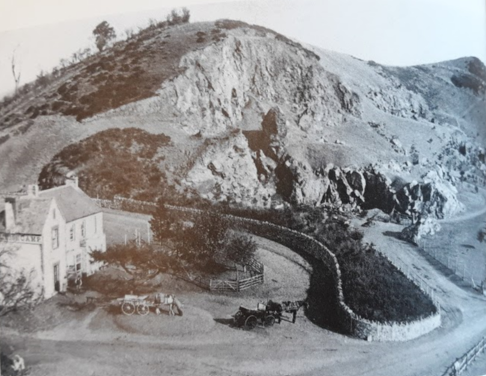
Early photograph of Wynds Point Quarry by Francis Bedford
Thomas Hyde (1784-1846) was most probably the quarry proprietor although most documents refer to him being a labourer or carpenter. This may be because during the mid 19th century local quarrying was carried out on an ‘as and when required’ basis rather than a seasonal or full time occupation. He married a local girl in 1808 taking her home to Well House, the cottage he had built in the extreme right-hand side of the quarry which was probably where the stone had already been worked out. This was a ‘squatters cottage’ similar to many on the hills although there is no record of any fine for its freehold being paid either to the Ecclesiastical Commissioners, being Lords of the Manor of Bosbury, Colwall and Coddington, nor to the Peyton’s being Lords of the Manor of Barton Colwall. However, the Tithe Apportionment of 1842 records Thomas Hyde as being both owner and occupier. Thomas had 2 marriages and a large family of 17 children, 13 of whom survived him, both wives dying in childbirth. Over the years Thomas most probably enlarged his cottage several times in order to accommodate his growing brood, which would explain the often recited theory that there were 2 cottages on this site.
Thomas made a fairly good living from the quarry as on his death in 1846 his estate was valued as being over £20 and in his will he left ‘my clock’ and ‘my watch and seals’, not the usual possessions of a rural agricultural labourer. Surprisingly, perhaps, his choice of Executor for his will was Reynolds Peyton of Barton Court, the Lord of the Manor of Barton Colwall, which raises the question as to whether their close relationship came from an interest in the quarry itself.
In June 1849, the arrival in Malvern of a Mr William Johnson (1799-1874) was announced in the Worcestershire Chronicle. He, together with John Johnson, was a stone merchant of Grosvenor Wharf, Milbank Row, Westminster, Middlesex (today’s Canary Wharf), a ‘landed proprietor’ and an inventor, patenting many of his railway carriage and saddle tree inventions. Adverts for granite ‘paving stones’ by the various London boroughs frequently appeared in the Morning Advertiser inviting tenders from stone merchants. It’s possible that William originally came to Malvern looking for new supplies of stone and whilst here stumbled upon the quarry and empty house at Wynds Point and decided to stay. It would appear that Reynolds Peyton had bought the house from the estate of Thomas Hyde, allowing William Johnson to build himself a new house on the site of the original cottage. Much of the house standing today, which is often attributed to having been built by Jenny Lind the Swedish Nightingale, was in fact built by William Johnson during the early 1850’s. In an October 1857 edition of the Worcester Journal newspaper, it was reported in The Telegraph by Mr Joseph Bennett on an appreciation of Jenny Lind that . . . . “I know well the residence at Wynd's Point which will always be called Jenny Lind's House and I have memories of the eccentric gentleman who raised it and built it round with walls of living and perennial green. He builded better than he knew."
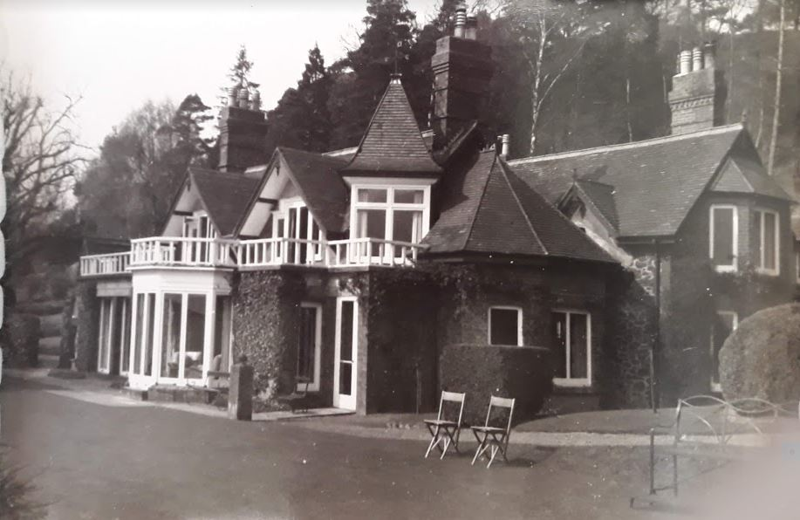
Wind’s Point

Courtesy Hereford Archives

And again in 1857 the Worcestershire Naturalists Society reported on “the very remarkable, contorted and disturbed strata of the caradoc, recently brought to light among the syenite at the Winds Point, from the excavations of Mr Johnson there in arranging the grounds at the back of his villa.”
Throughout the late 1850’s and early 1860’s Mr Johnson and the Worcester Turnpike Trustees were in constant disagreement about the boundaries of his property and the condition of the turnpike road in front of his house which was often washed away or blocked by falling trees and boulders. Mr Johnson decided to build one of the new Macadam roads spending much time and his own money making the road what he thought it should be. ‘Tickling the toes of the Hill’ as he called it, whereby the north and west side was blasted and the quarried rock cast to the eastern side of the road building up the camber above Little Malvern Wood and strengthening the edge of it. By cutting off projecting masses of rock on the west he made the sharp turns of the old road into the sweeping curve we know today, widening and making it safe at the same time. But the turnpike surveyor was not happy. Cases were brought against Mr Johnson by the Worcester Turnpike Trust culminating in 1863 with an injunction against him to leave the road alone, which was just as well as by then he had run out of money. C.F. Severn Burrow in her book ‘A Little City set on a Hill – The Story of Malvern’ tells us that there was need of a ‘whip round’ to pay the roadmen their final wages.

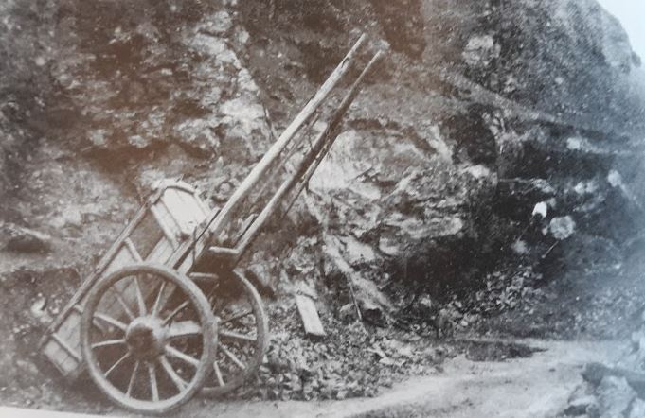
Quarrying at Wynds Point – Transport was by horse and cart - c1860’s

Despite the scarcity of documentary evidence it is obvious that the quarry throughout this time was still working for in November 1861 the Hereford Times reported:-
‘On Tuesday an accident happened to Mr Charles Matthews, foreman at the Wind’s Point Quarry Works in Colwall. He was at the time of the accident standing at the bottom of a mound of soil at the top of which they were moving stone, when a weighty one was displaced and rolled down against Mr Matthew’s foot before he could make his escape, he being between the stone and cart. His ankle was put out and he received some other injuries but under the treatment of Dr Hamilton of Malvern, he is going on well.’
And, in 1867, The Worcester Journal printed an advertisement from the Upton Upon Severn Turnpike Trust inviting tenders for the hauling of stone:-
“To the point where the Upton and Worcester Trusts meet at Little Malvern from the Lake Bridge. Stone to be hauled from the Quarry, Little Malvern at Wind’s Point.”
The Electoral Roll for Herefordshire 1874 records William Johnson as being in occupation of the house and land at Wynds Point as ‘Tenant’, which is surprising when he obviously put so much of his time and money into building the house and its surrounding environment. When he died in that same year, his Executor was Thomas Griffith Peyton, younger brother of Reynolds (1814-1861), the then current Lord of the Manor of Barton Colwall. William Johnson bequeathed all his real and personal estate to Thomas Peyton of Barton Court, leaving nothing to his daughter Augusta Coleman or grandson Edward, (born the previous year) who were then living at Hawkchurch, Devon. His estate was worth less than £200.
No mention is made of the house in the advertisement below, only its contents.

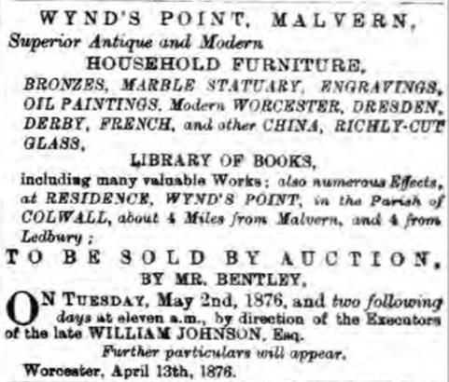
Perhaps it was Thomas Peyton who provided the funds to pay the roadmen’s wages which is why William Johnson left everything he possessed to him in order to pay this debt.
In October 1882, the Berkshire Chronicle reported that Jenny Lind had recently purchased a house at Wynds Point, presumably from Thomas Peyton. One of the biographies about her life mentions ‘difficulties’ in completing the purchase of the property. In June 1883 Thomas Peyton was required to ‘reswear’ William Johnsons’ will presumably because it was discovered that the quarry was still legally part of the ‘waste’ of Colwall, the freehold having to be sought from the Church Commissioners. Jenny Lind or more accurately, and as she wished to be known, Madam Goldschmidt, set about making numerous alterations and additions to the house and grounds, one of which was to create a driveway with the addition of a lodge at the new entrance to the property. The previous road out of the quarry had been through ‘Pockets back yard’ onto Jubilee Drive, Peter Pocket being the landlord of what is today the Malvern Hills Hotel.
At her death in 1887 Jenny Lind devised the freehold of the estate to her husband Otto Goldschmidt, who kept the property until 1897 when it was bought jointly by George and Richard Cadbury as a family summer retreat.

In 1886 Mr G E Mackie, one of the masters of Malvern College, informed members of The British Association that the quarry in the grounds of Jenny Lind's home, where they were standing, had closed 10 years previously.

William Johnson died in 1874, the quarry’s job was done - the new road had been built.

Going . . . . .
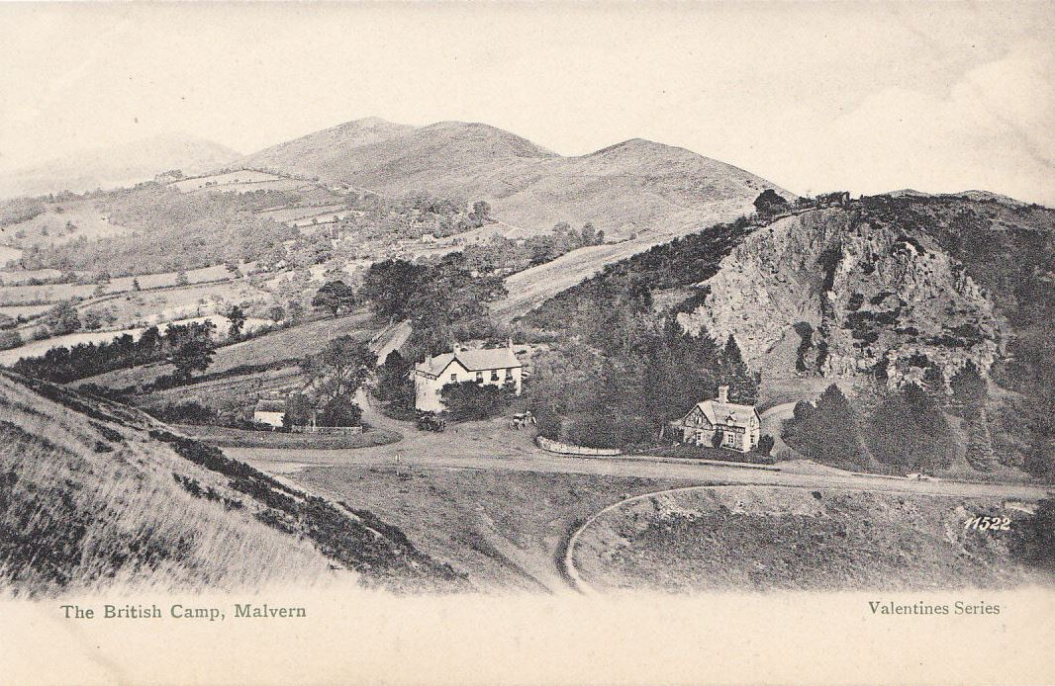
Courtesy – Herefordshire Archives & J Valentine & Sons Ltd. c1885

Going . . . . .

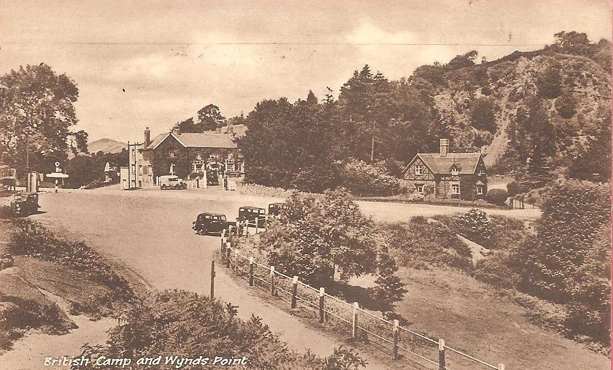
Gone . . . . .
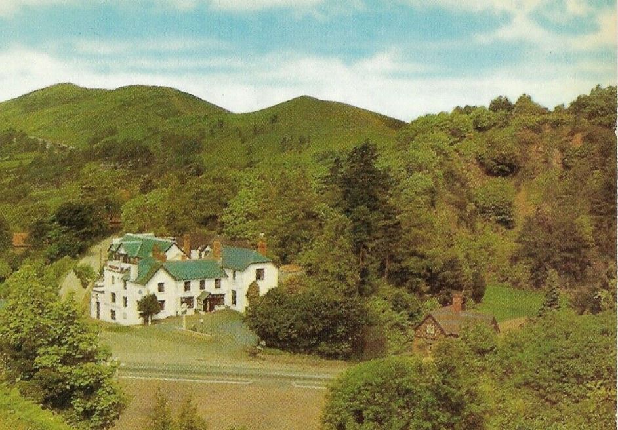
. . . . . with a little help from Mr Johnson, Jenny Lind and the Cadbury family.

